**Implement Azure WebApps**

Open Azure Portal Click on New Web + Mobile and Click on Web App

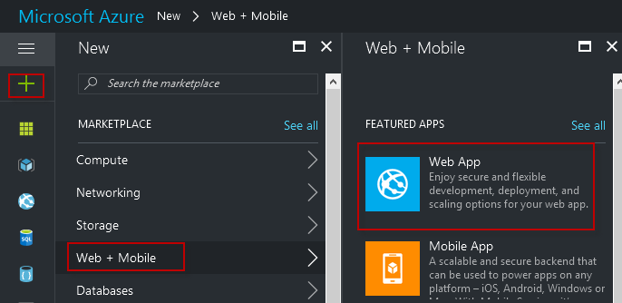

Create WebApp

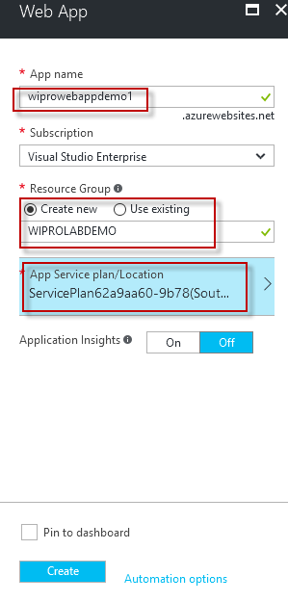

Create New App Service Plan

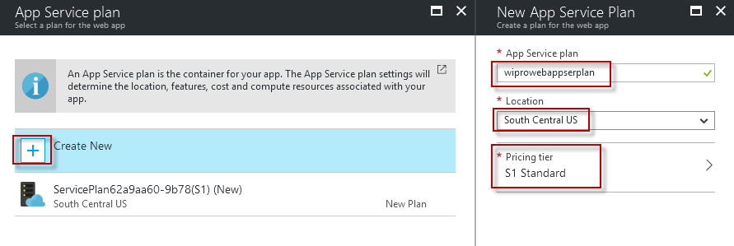

Select Pricing Tier

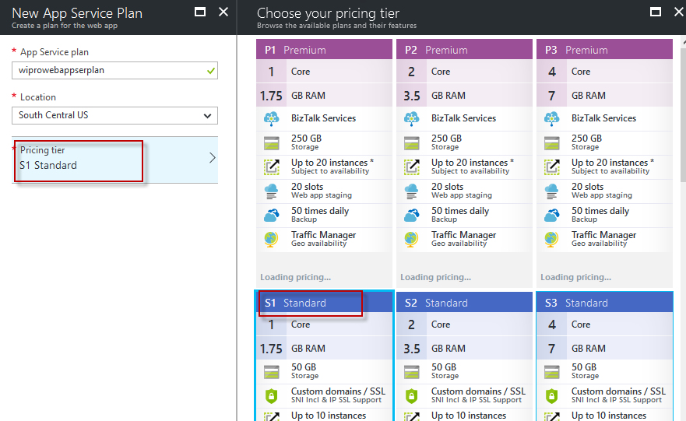

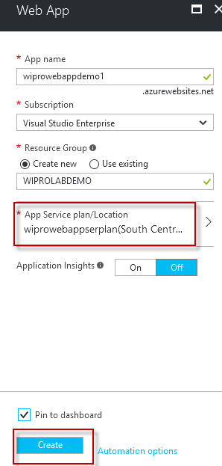

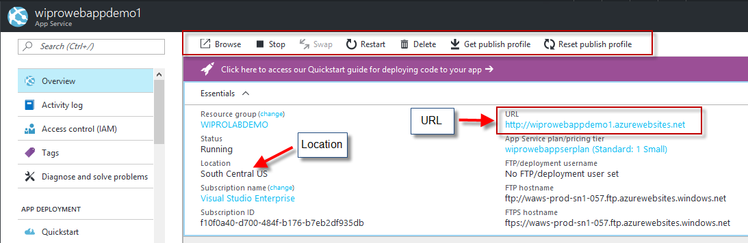

Download Publish Profile

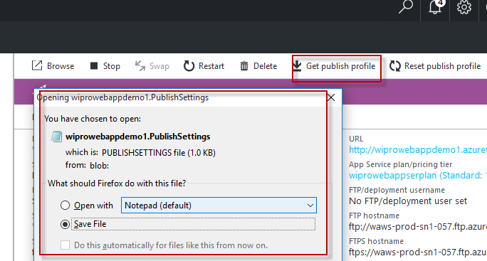

Copy Credentials to access wwwroot of your webapp

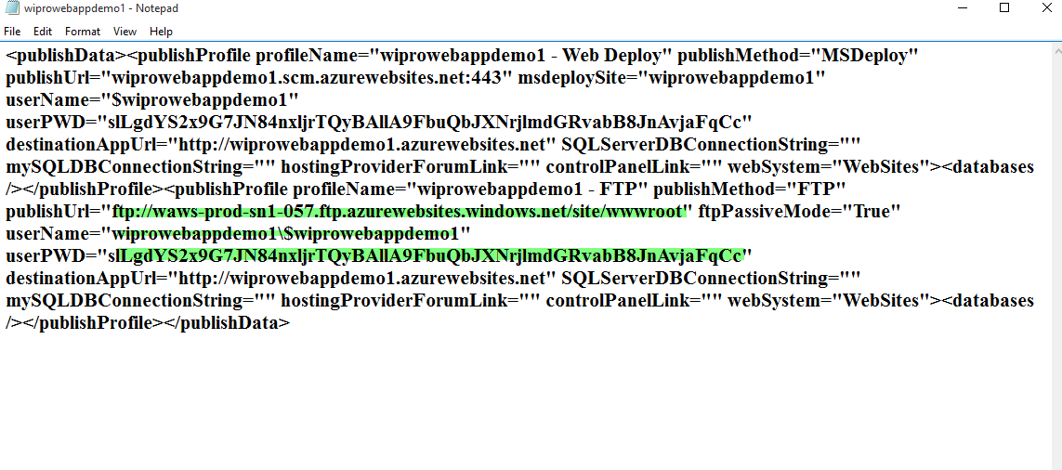

Use File Explorer to access wwwroot

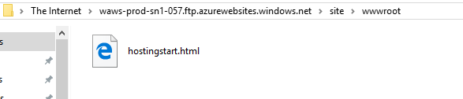

Create index.html page in local machine and copy and paste html file in File Explorer

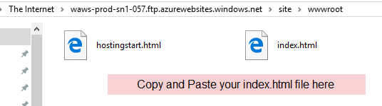

WebApp Published

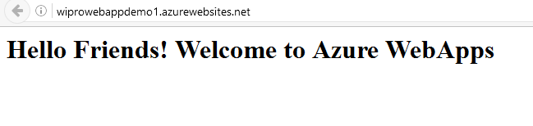

Now Add One Deployment Slot

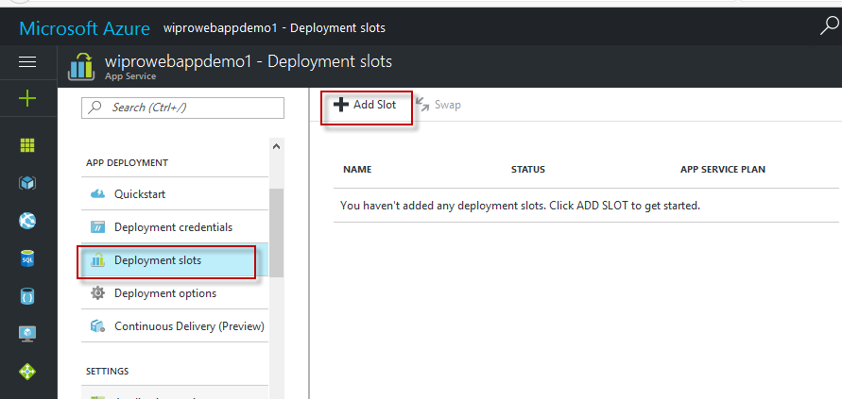

Add a Slot Name

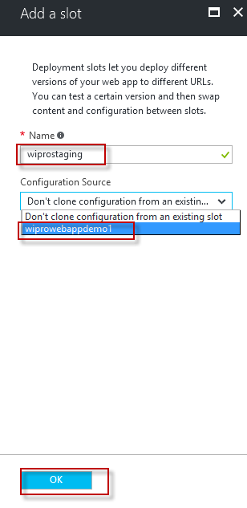

Now Open github.com (Create your Account FREE) and Login than Click on New Repository

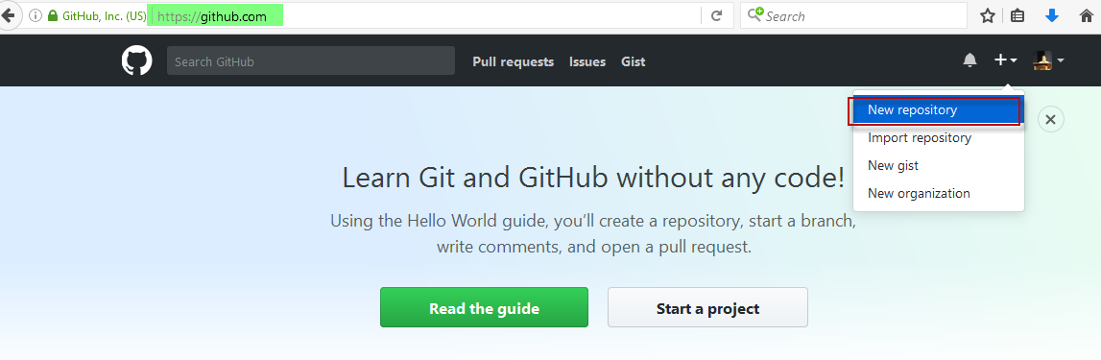

Than Create wiprodemo repository and Click on Upload Files Button shown below

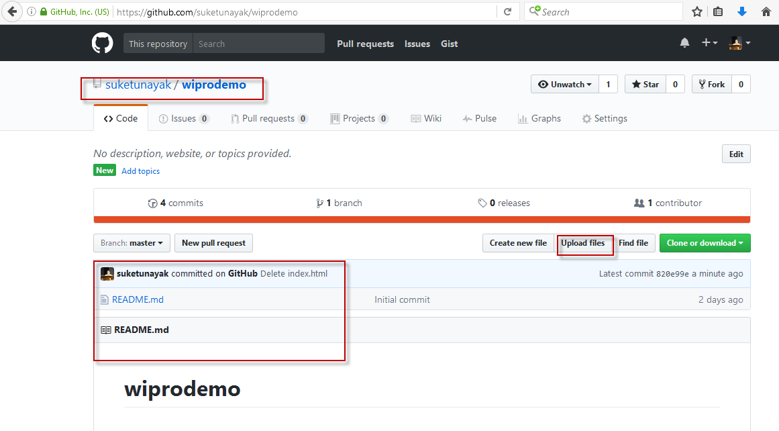

Now edit that index.html page to version 1.0 in local machine and upload here in github (Upload using Drag and Drop) - > Click on Commit Changes

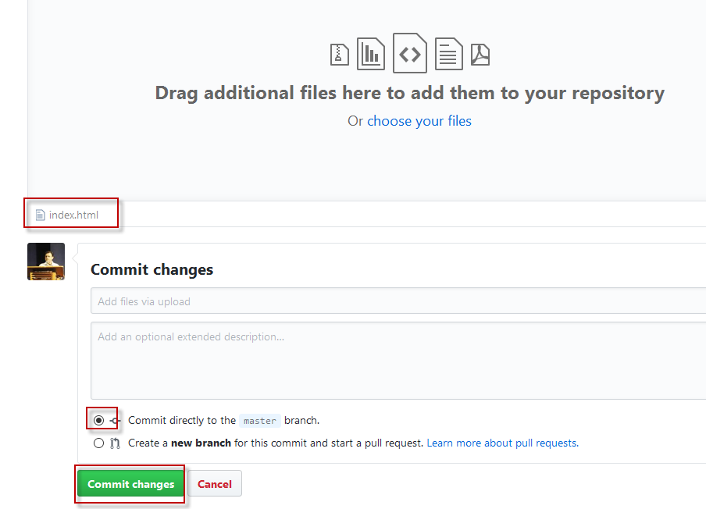

Now you have two webapps one main webapp and one staging slot webapp

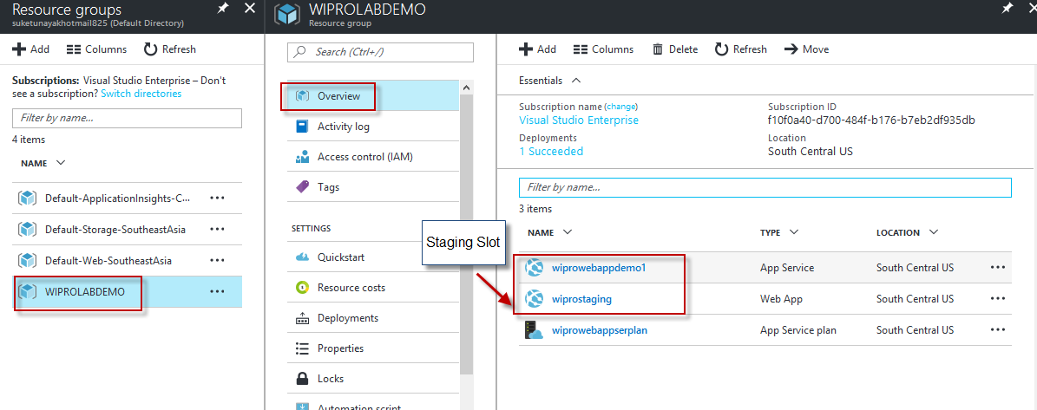

Now Click on wiprostaging (Staging Web App) -> Click on Deployment Options in menu

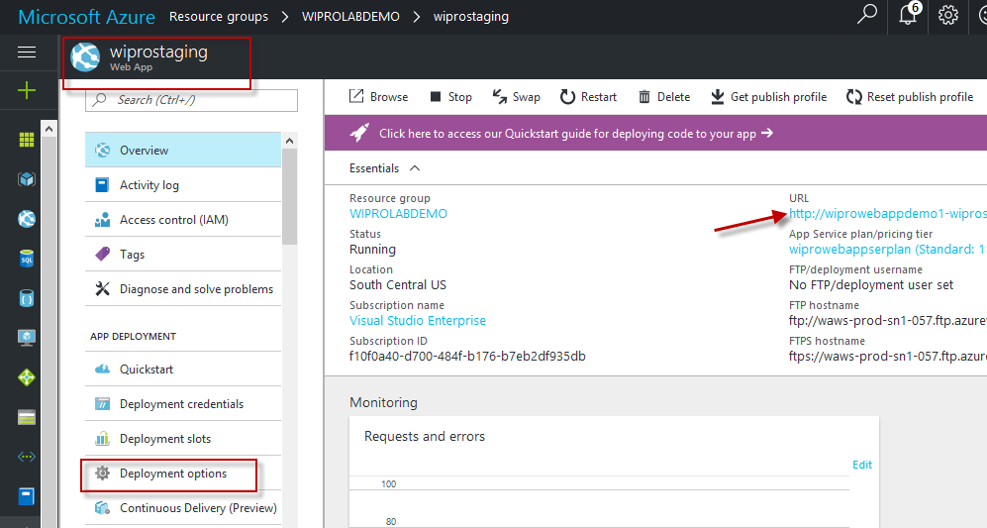

Below is list of Deployment Options, Choose Github (Sign in with your github credentials)

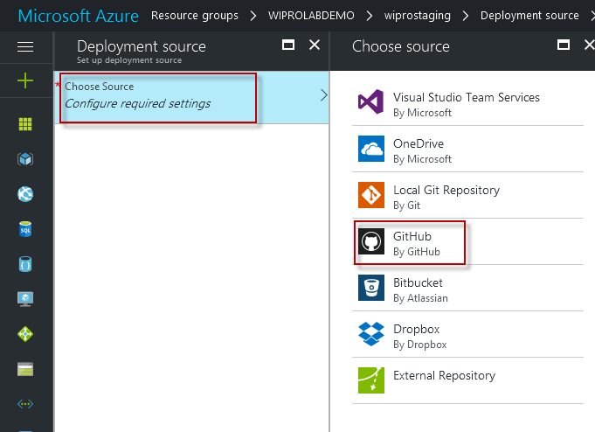

Than Choose Project wiprodemo

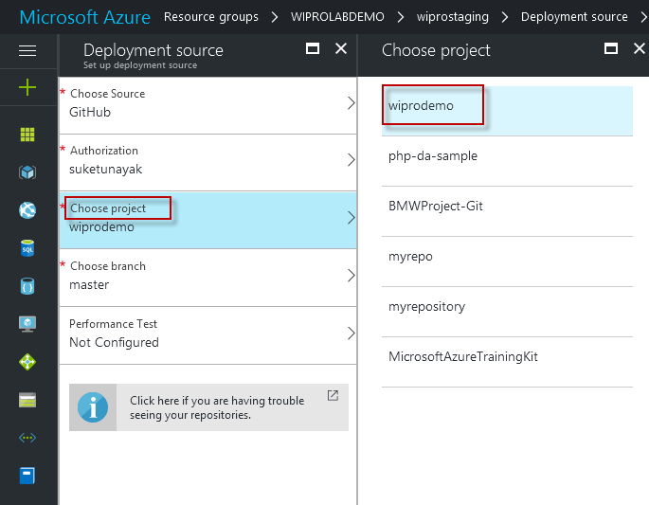

Now Click on staging URL and see Version 1.0 is ready in staging slot

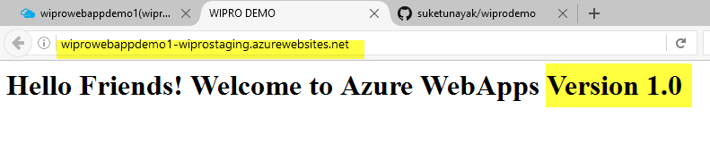

Now Click on Main WebApp and Click on Overview and Click on SWAP Button

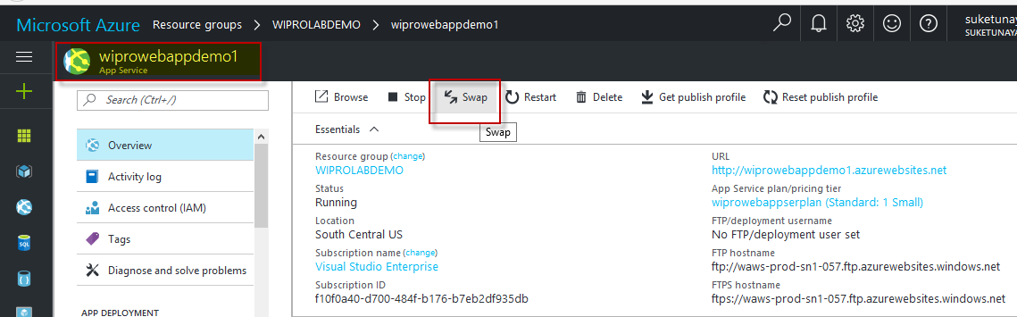

As we know Version 1.0 of our webapp is in staging slot we want to swap it on Production so select Source and Destination (Production – Main Webapp).

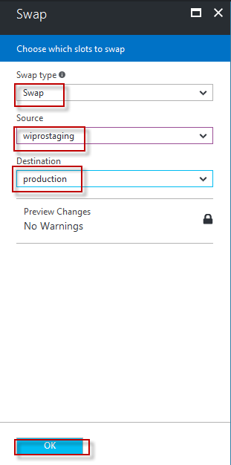

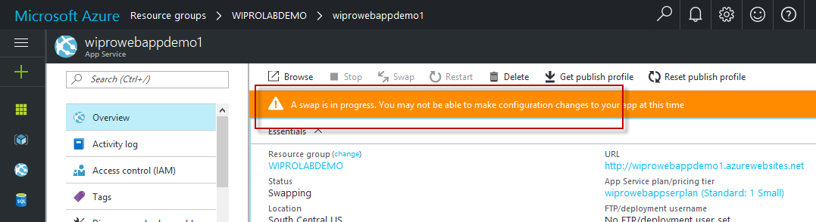

Now you can check Main WebApp URL Version 1.0 is Launched in Production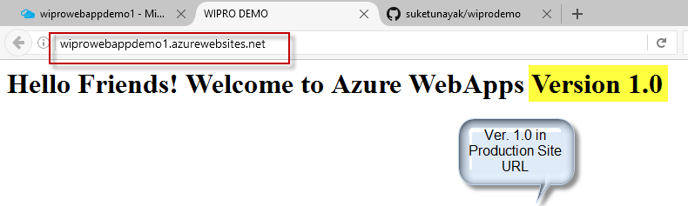

Now in below option Application Settings you can select multiple language platform accordingly your language of web application.

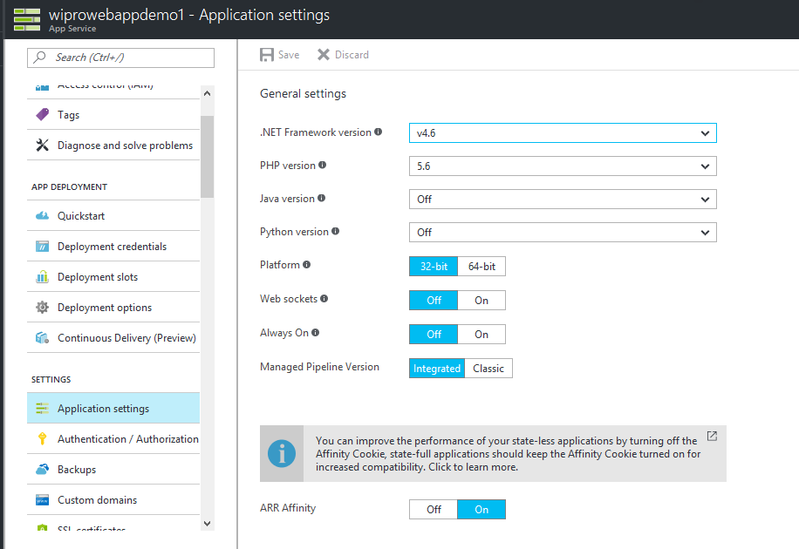

In same option Application Settings you will find Default Documents (Home Page), Here you can set your custom page as a start up page.

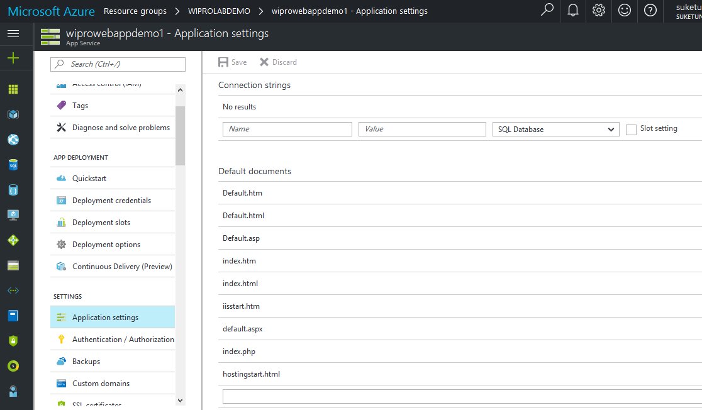

In Connection Strings option also you can pre define your connection strings of SQL Database, SQL Server, MySQL or custom of your application.

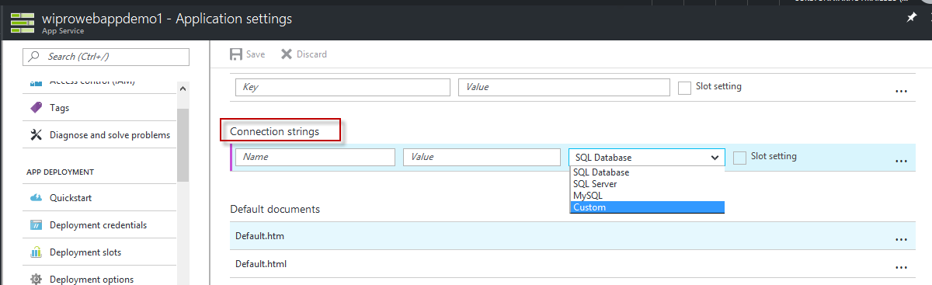

In Same option page we can also configure Virtual Applications and Virtual Directories, Like we added Blog Directory in wwwroot folder and click on Check Box Application.

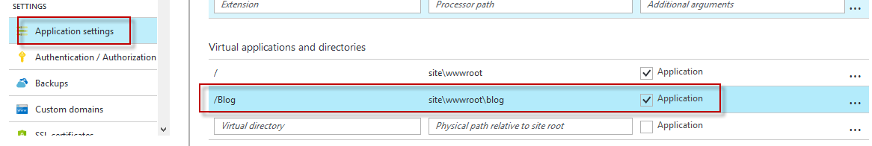

Now Create one sample index.html file like Hello Blog File and Once again Open Publish Setting File and access wwwroot folder -> Inside wwwroot create blog folder and paste index.html page in File Explorer.

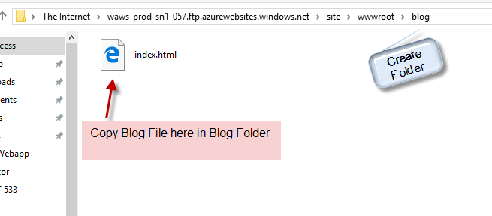

Open WebApp URL and append /Blog and Click Go in Browser your Blog Page will be available in Browser.

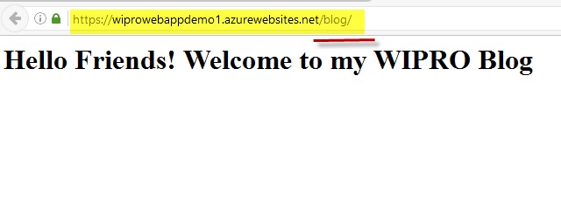

Advanced Tools (Kudu) - you need to add .scm. in between your webapp URL (In Same Browser) and Kudu will be loaded of your webapp.

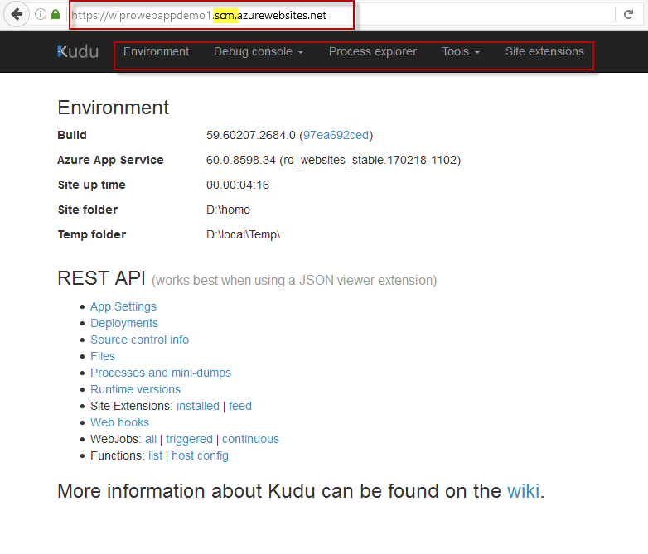

For Diagnostics and Logging of your WebApp Click on Diagnostics Logs Menu and You can Select ON and OFF for various types of Logs

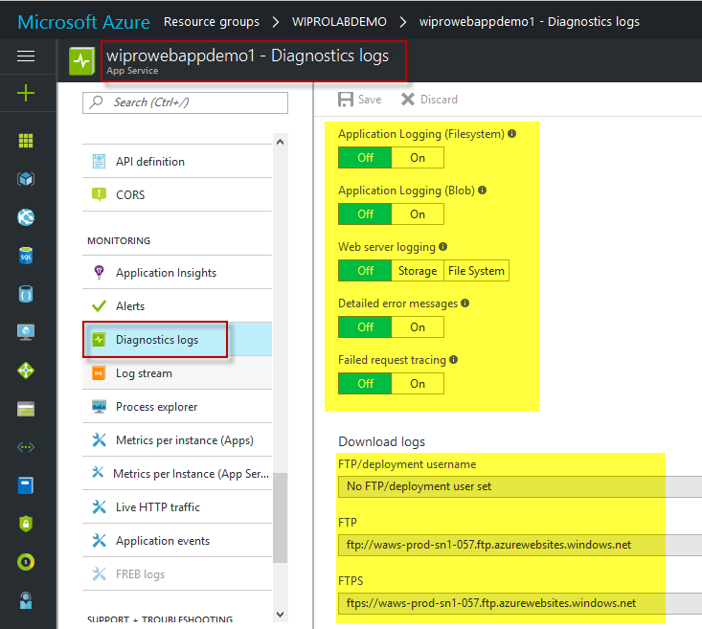

Below is Auto generated Paths of Log Files

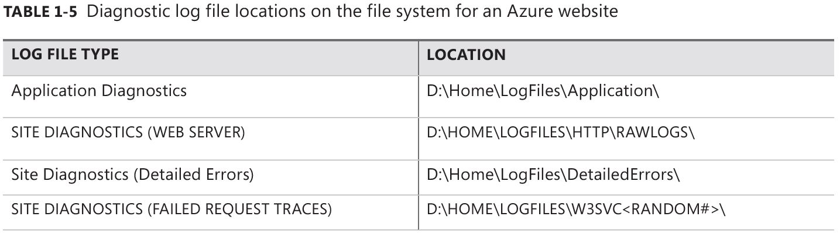

For Performance Test click on Performance Test Menu and Click on New and Create New Performance Test for your WebApp.

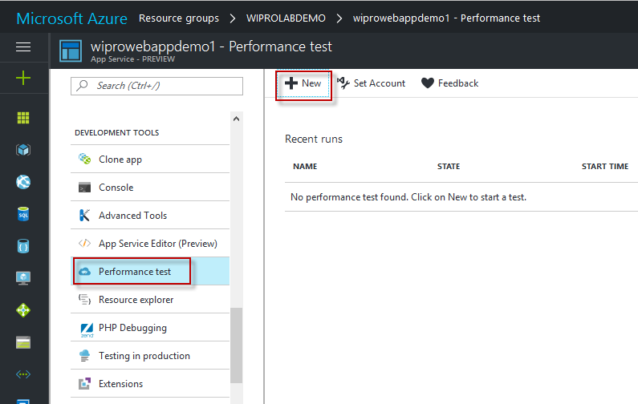

You can set User Load and Duration for Performance Test of your WebApp

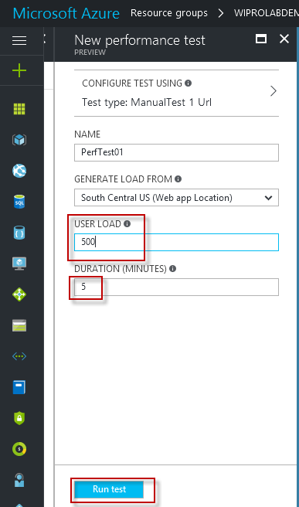

After 15 Minutes You can check results

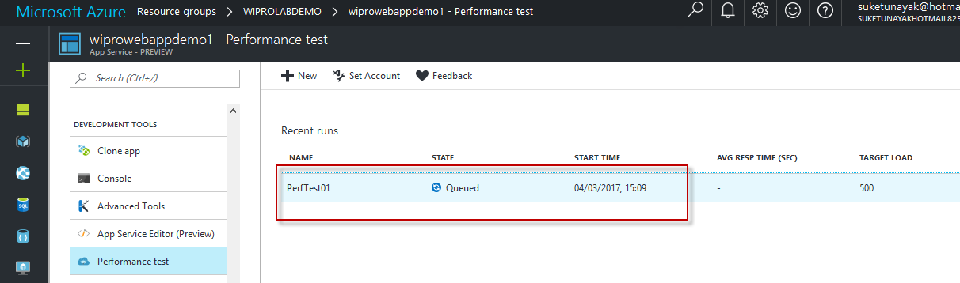

And you can check performance matrices and charts of your webapp

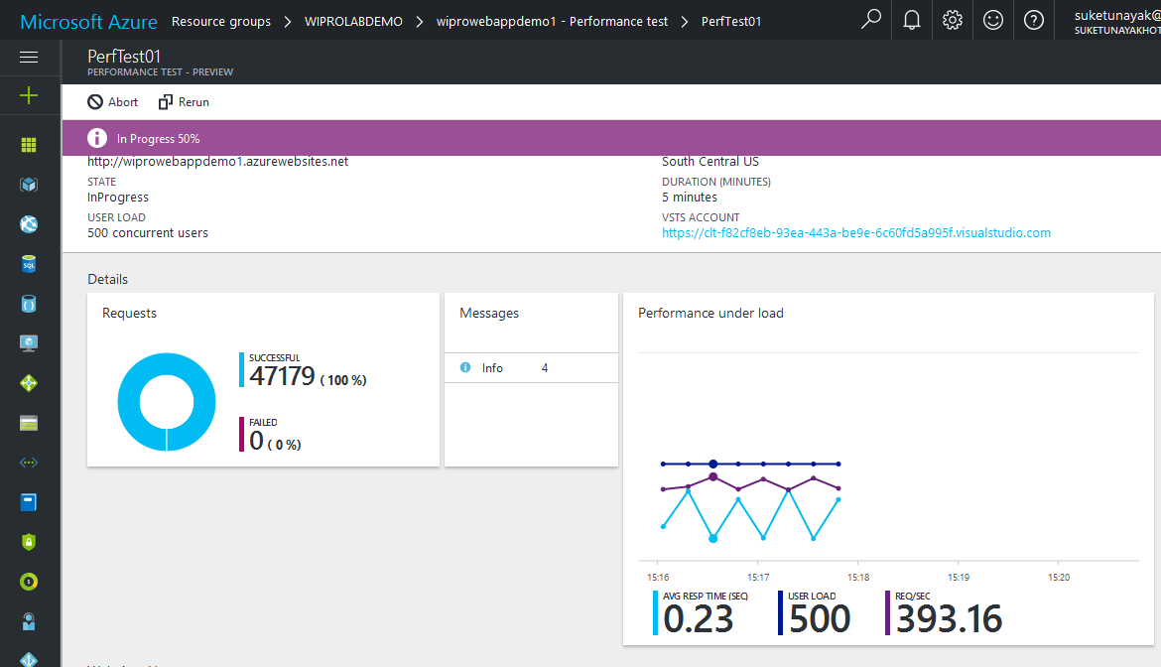

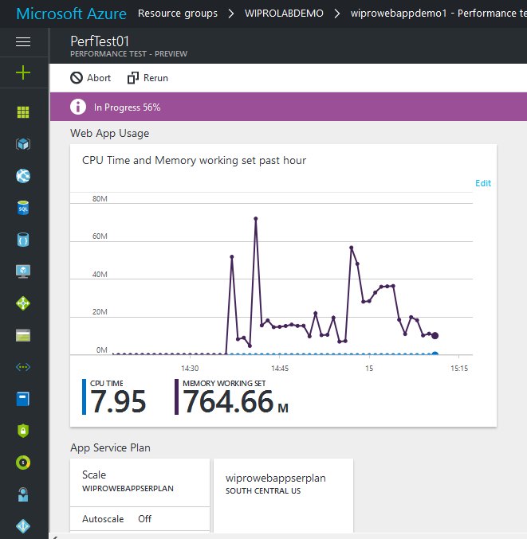

Now we can create Alerts for WebApp

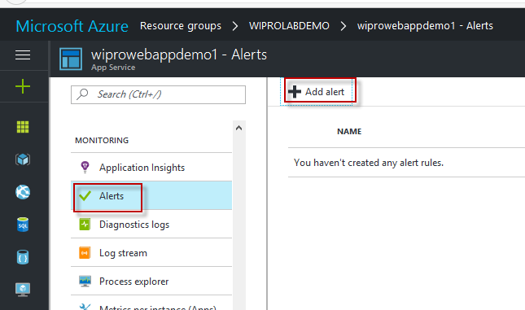

Add Alert Details, We have two options Metrics or Events, I Selected Matrics

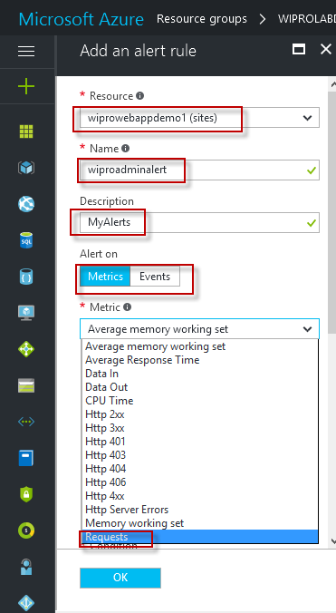

Set Condition, Threshold, Period and also given Email ID for receiving alerts.

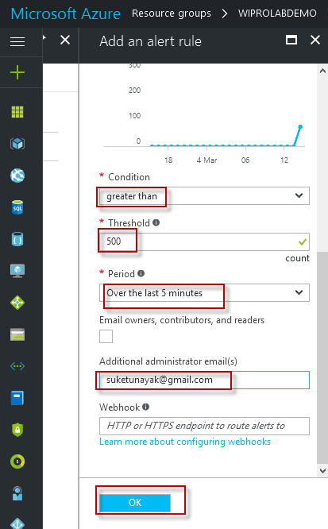

Meanings of Metrics

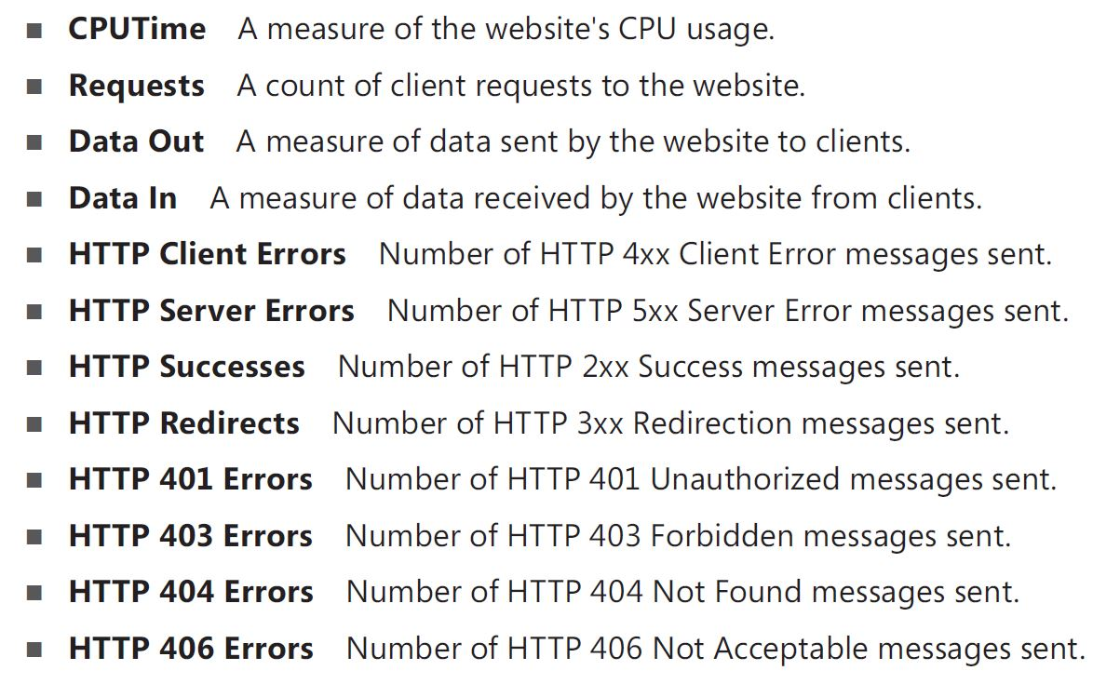

To Change Application Service Plan Click on Scale Up and we can scale up.

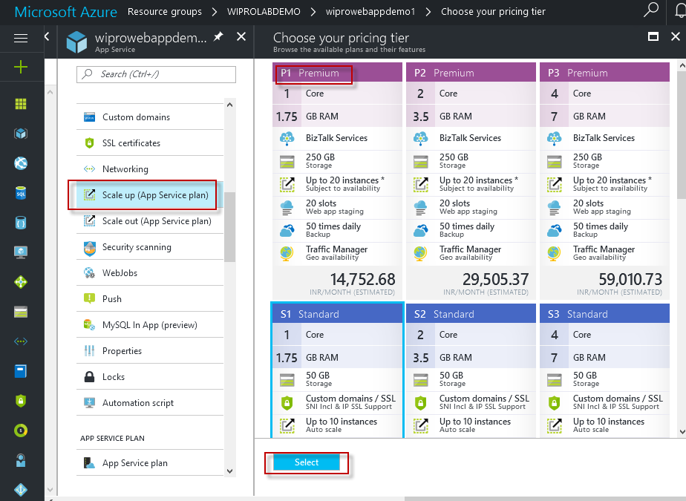

For Scale Out we can click on that option and Select Scale By Option and also set max. instance and Target Range

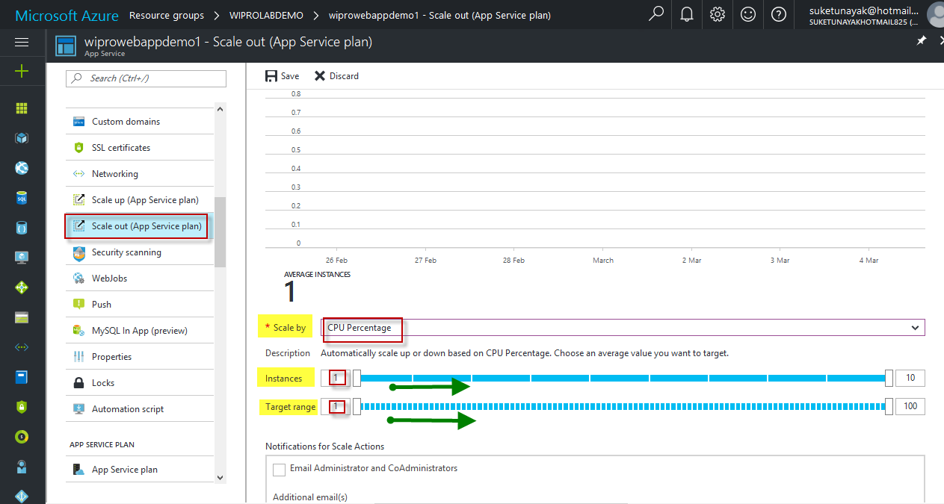

For SSL Certificate Click on that Menu and If you purchase SSL Certificate from Godaddy or Bigrock.com than you can import certificate here and add binding with you webapp. So your WebApp will be in https:// and SSl Secured.

